Starviewer is an application for the visualisation and navigation of medical images using the DICOM protocol. It supports different modalities: X-ray, CT, magnetic resonance, mammography, RF, ultrasound and others. It can communicate with any PACS or obtain images from external files.

How to find a study in the PACS
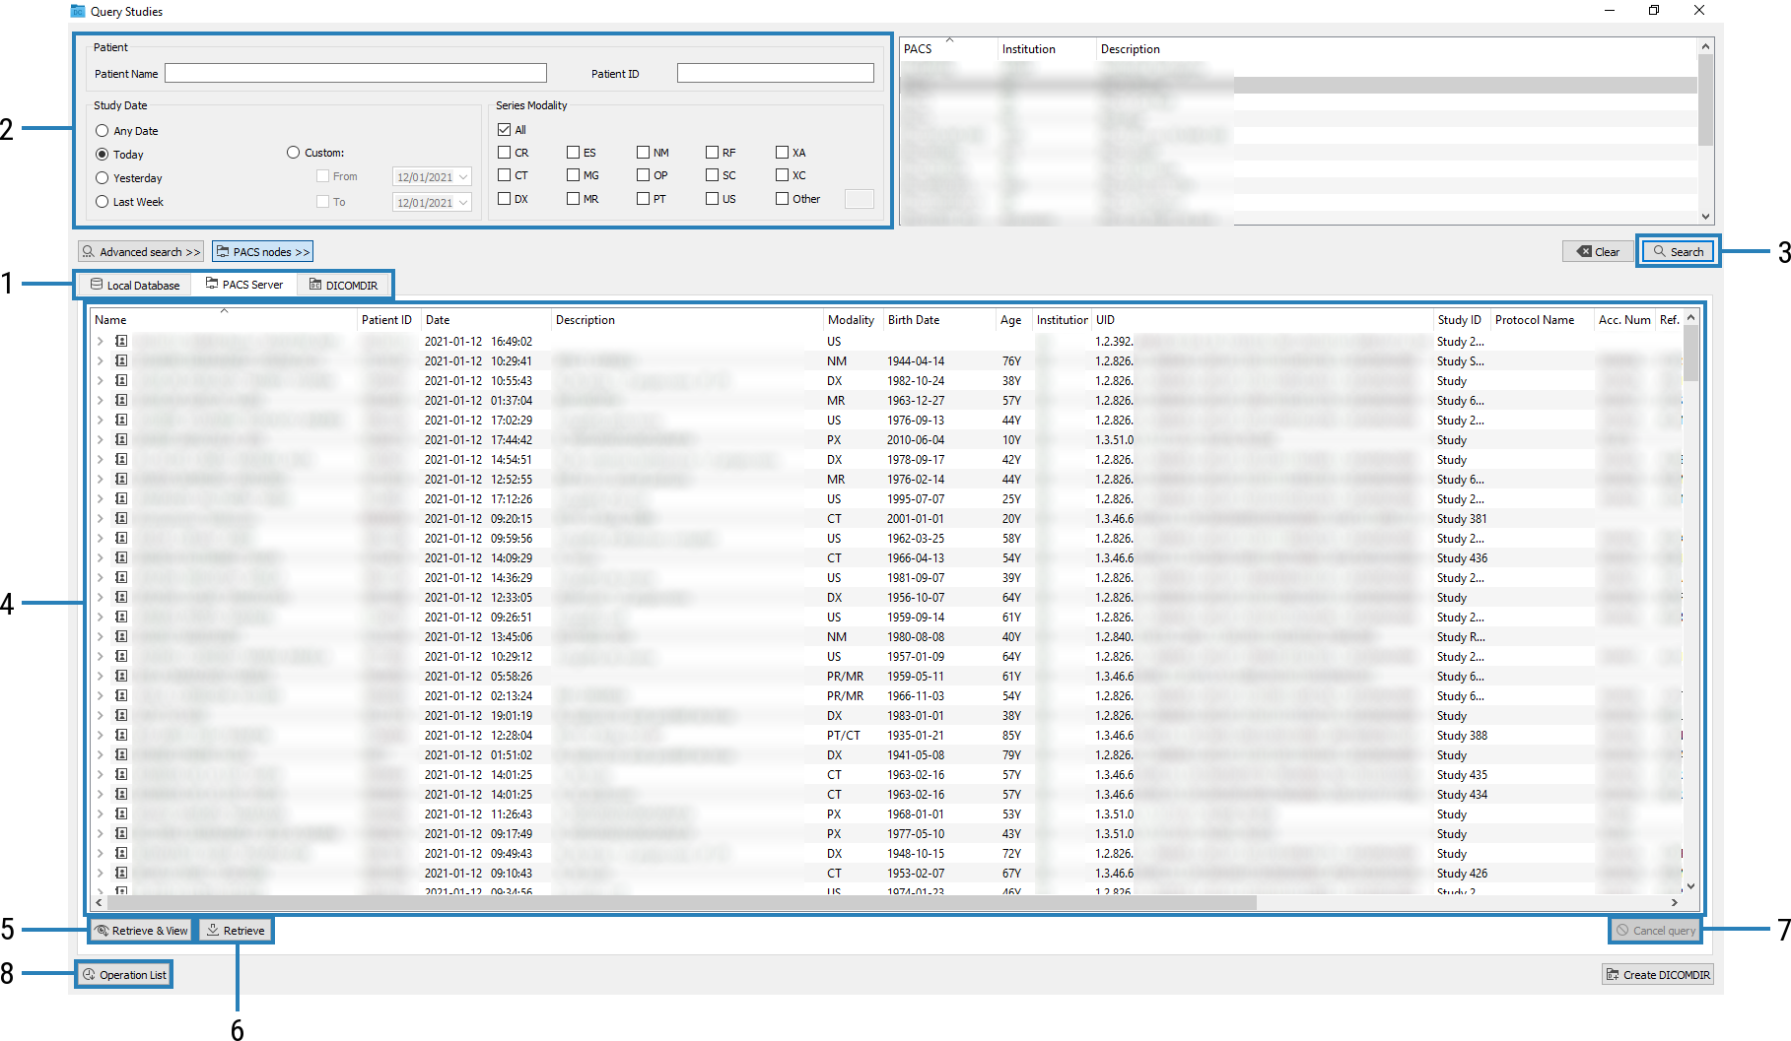
To look for a study in the PACS, go to the File > PACS… menu or use the Ctrl+P shortcut. A window like the following one appears:
Then, the following actions can be carried out:
- Check that PACS Server tab is selected.
- Enter query parameters: patient name, study date, etc.
- Press the Search button or the Enter key.
- Select one or more studies from the list.
- Press the Retrieve & View button so that the study is automatically retrieved and opened.
- Alternatively, if the study only needs to be retrieved and not viewed, press the Retrieve button.
- To cancel the query before it ends, press the Cancel query button.
- The Operation List button allows checking the status of the retrievals.

Choose series of the study
- Right-click  inside a viewer.
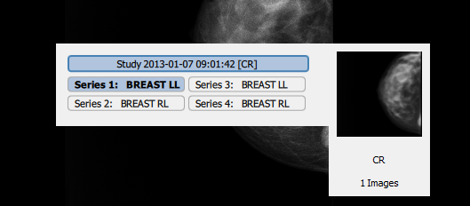
- Select a series from the list.

Contrast and brightness (windowing)
- Hold down the right mouse button  inside a viewer.
- Drag the mouse horizontally (width/contrast) or vertically (level/brightness).
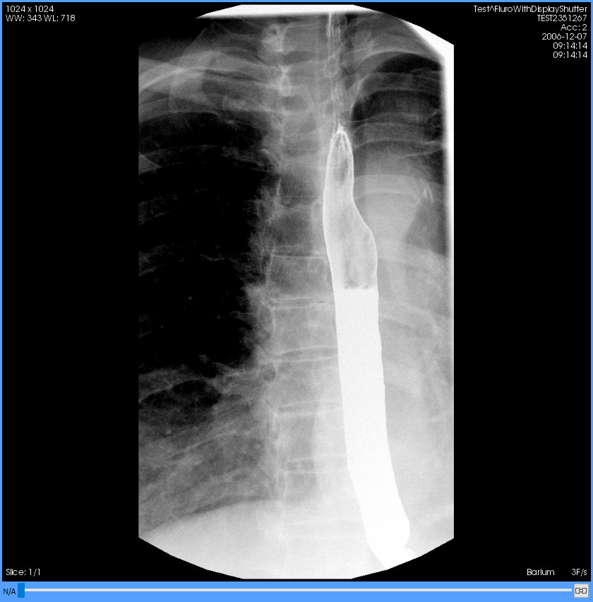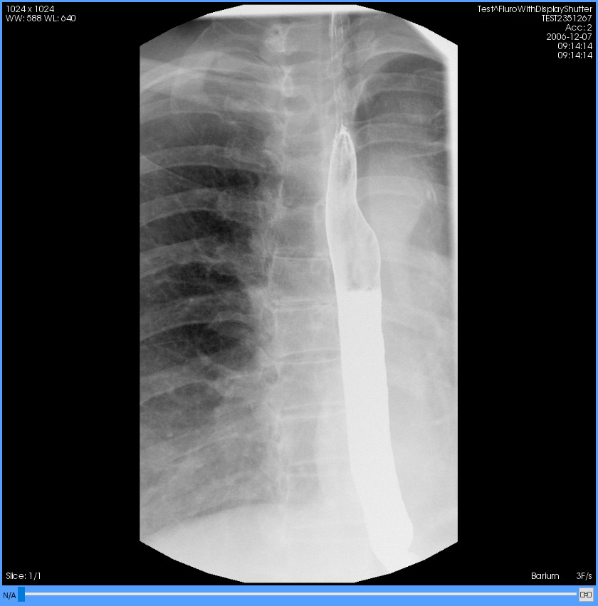Figure 1: Left: original DICOM window. Right: modified window.

The tools
Scroll and phase change (dragging the mouse with the left button or spinning the wheel).
Zoom (dragging with the left button).
Pan (dragging with the wheel).
WW/WL or windowing (dragging with the right button).
Magnify: it magnifies a region of the image (dragging with the left button).
Distance: it calculates the distance between two points.
TA-GT.
Angle: it measures an angle by setting three points.
Cobb angle: it measures an angle by drawing two lines that do not touch each other.
Elliptical ROI: it draws an elliptical ROI and calculates its area, mean and other data.
Polyline ROI: a ROI by setting the points manually.
Magical ROI: a ROI that adapts to shapes automatically.
Circle: it draws a circle and indicates its centre.
Arrow.
Erase/Erase all: they erase the drawings made with the previous tools.
Regular layout/Hanging protocols: they change the viewers’ layout.
Related studies: it directly accesses other studies of the patient.
Axial/Sagittal/Coronal: they change the image reconstruction.
Rotations in 90° increments.
Horizontal and vertical flip.
Invert colour scale.
Restore the viewer to the initial state.
Reference lines: it shows the location of the current image in the other viewers.
3D cursor: it marks a point in a viewer and finds the same point in the other ones.
Voxel information: it displays the value of the voxel under the pointer.
It shows or hides textual information of the image in the viewer.
Screenshot of an image or the entire current series in image format.
It creates a new series in the study with the viewer’s content and sends it to the PACS.
DICOM information: it displays all DICOM information in a floating window.
Auto-sync: it synchronises to the same position in space the viewers it can.
Manual synchronisation: synchronised viewers are moved the same distance.
Propagation: it synchronises some properties of the viewers.
Thick slab: it visualises a MIP with the desired thickness.

